**Assignment 12.2 Scala**

**Problem Statement:**

**Given a list of strings - List[String] (“alpha”, “gamma”, “omega”, “zeta”, “beta”)**

**Solution:**

**val names = List("alpha ", "gamma", "omega", "zeta", "beta");**

**Q1 - find count of all strings with length 4**

**object** ScObj1 {

**def** main(args: Array[String]): Unit = {

**val** names = List("alpha", "gamma", "omega", "zeta", "beta");

**val** x2= names filter (_.length == 4)

println(x2)

println("Count of string " + x2.length)

}

}

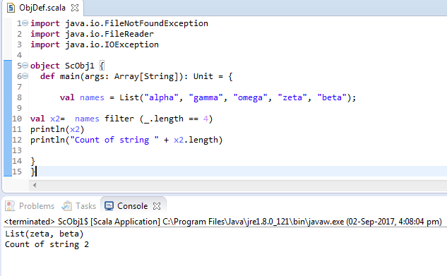

**Q2 - convert the list of string to a list of integers, where each string is mapped to its Corresponding length**

**import** java.io.FileNotFoundException

**import** java.io.FileReader

**import** java.io.IOException

**object** ScObj1 {

**def** main(args: Array[String]): Unit = {

**val** names = List("alpha", "gamma", "omega", "zeta", "beta");

**val** namelne = names map (_.length())

**val** nameint =names map (_.toList.length)

println (namelne);

println (nameint);

}

}

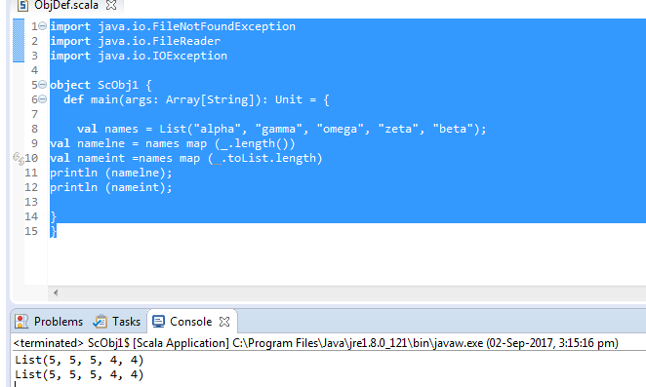

**Q3 - find count of all strings which contain alphabet ‘m’**

**import** java.io.FileNotFoundException

**import** java.io.FileReader

**import** java.io.IOException

**object** ScObj1 {

**def** main(args: Array[String]): Unit = {

**val** names = List("alpha ", "gamma", "omega", "zeta", "beta");

**for**(a <- names)

{

**if**(a.contains("m"))

println(a);

}

}

}

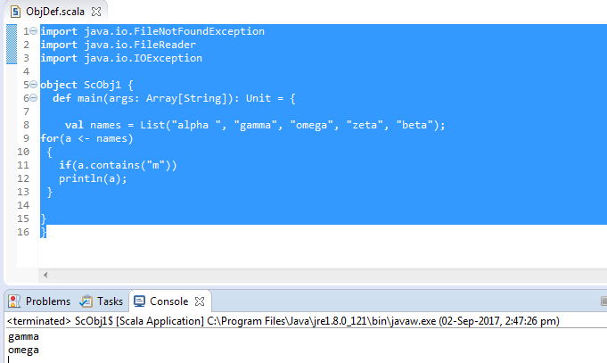

**Q4 - find the count of all strings which start with the alphabet ‘a’**

**val names = List("alpha ", "gamma", "omega", "zeta", "beta");**

**for(a <- names)**

**{**

**if(a.startsWith("a"))**

**println(a);**

**} ;**

